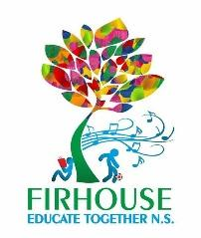
Firhouse Educate Together National School,
Ballycullen Drive, Firhouse, Dublin 24
Tel: 01 4061010 Email: firhouseetns@gmail.com www.firhouseetns.ie

Booklist/Resources for Senior Infants 2022/23

Dear Parents and Guardians,

_ _ _ _ _ _ _ _ _ _ _ _ _ _ _ _ _ _ _ _ _ _ _ _ _ _ _ _ _ _ _ _ _ _ _ _ _ _ _ _ _ _ _ _ _ _ _ _

The following are supplied by the school and we will send you an online payment request shortly for €120 to cover same, payable by 30th August 2022.

Pupil Personal 24-hour Insurance €8.00

Book Rental Scheme:
(Includes selection of graded readers, supplementary readers,
parallel readers - large / small format books); €20.00

Sights & Sounds B €2.50

Photocopying/Online Resources €25.00

Copies for the year, folder and document wallet, additional stationery €19.50

Arts & Sports Materials €30.00

Membership of Educate Together €15.00

Total Cost €120.00

Art: Please provide an old large t-shirt to wear over clothing for art, which will be kept in school - Please make sure to put your child’s name on it and on all clothing they bring into school

